Article for Local Preachers’ Training – Key aspects of Methodist history and contemporary identity – The Love Feast
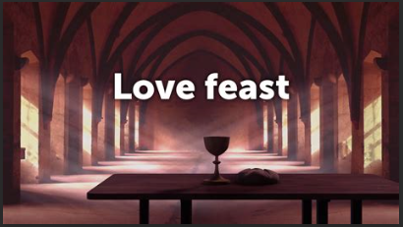
You will have noticed on our plan there are a number of services that are noted as ‘Love Feast’ across the next three months. There have been a number of questions about this so I thought it was an ideal opportunity to explain a little about the ‘Love Feast’ service.
The Love Feast goes right back to the very start of the New Testament Church.
From the very earliest days of Methodism, thanks to Wesley himself, the Love Feast has been part of our services. However, over the last century it has been very much ignored in our country.
Eating meals together regularly has been part of the church since the first Christians. In Acts we read of Deacons being needed to serve in the distribution of food at tables. In 1 Corinthians we read of those who abused the Lord’s Supper by consuming to much food and drink. We can presume this was more than a communion glass and a square of bread.
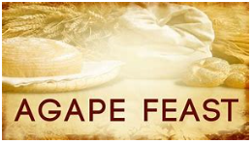
These meals were Eucharistic in nature, with bread and wine formally offered. They also had a Love Feast element, food was shared and the hungry fed. Gradually there was a separation of the two elements. They became two events ‘The Love Feast’ also known as the ‘Agape’ and the ‘Eucharist’.
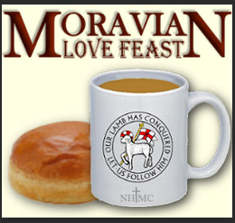
In the fourth century, due to other mysterious religions having their own Love Feasts the Agape was banned. Fourteen centuries later, Wesley reintroduced them. On his way to America, John Wesley encountered the Moravians and brought the Love Feast back from his encounter with them.
Wesley’s genius was to see what would work in that time and go with it. He saw an opportunity to deepen fellowship, encourage testimony and allow the Holy Spirit to work. The Love Feast was exciting and helped fuel the Revival.
There is testimony to the power of the Love Feast in his journal, from 1739 we hear:
“Mr. Hall, Kinchin, Ingham, Whitefield, Hutchins, and my brother Charles were present at our love-feast at Fetter Lane, with about sixty of our brethren. About three in the morning, as we were continuing instant in prayer, the power of God came mightily upon us, inasmuch that many cried out for exceeding joy, and many fell to the ground. As soon as we were recovered a little from that awe and amazement at the presence of His majesty we broke out with one voice: "We praise Thee, O God; we acknowledge Thee to be the Lord."
In recent years the Love Feast has been revived. It is often used in Methodism where there is no one present authorised to administer the Sacrament or when people from different denominations are present and do not feel free to share Holy Communion together. One of the advantages of the Love Feast is that any Christian may conduct it. In 2019, times are changing in our churches, with fewer Ordained Ministers we are likely to see an increase in Love Feasts.
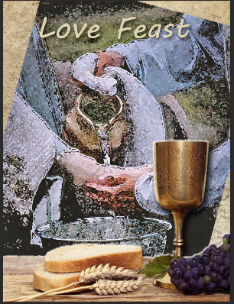
Yours in Christ
Ed

