Article for Local Preachers Training –
Discerning calling and vocation – My Call to Preach

As brief introduction, I just wanted to explain, the new local preacher training by the Methodist Church requires new and varied ways of assessment. One is to write a short article for publication in the Church magazine or the like, so here is where I find myself.

As most of you will know I have started on a new journey, stepping out in faith on the path to be a local preacher. The start of this journey was 11 years ago in a service at Wisewood Church in Sheffield, led by Rev Maurice Stafford. I clearly felt God saying to me that he had something bigger he wanted me to do but this was not the time and to be patient.

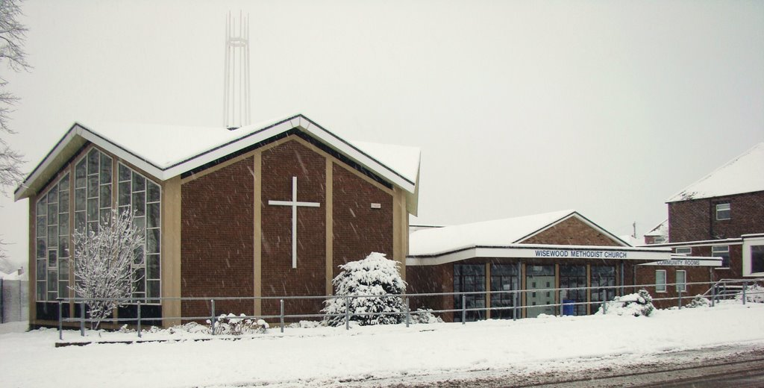

Psalm 37.7 (New Living Translation) – “Be still in the presence of the LORD, and wait patiently for him to act”.

At that time, I had been a Christian for 20 years or so and God had already taken me on a few exciting adventures. This was a time to wait.

When I was at ECG in 2017, I felt a strong tap on the shoulder from God. Now God was acting and my patient time was over. After a little discernment over a few hours and days the mists cleared and the path I strongly felt compelled to take was clear.

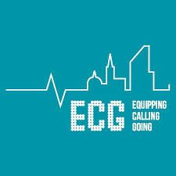

Isaiah 6.8 (New Living Translation) – Then I heard the Lord asking, “Whom should I send as a messenger to this people? Who will go for us?” I said, “Here I am. Send me.”

As part of the study in training to be a local preacher there is much reading. Reading to study, reading to expand knowledge, reading to prepare for different aspects of the service, reading to formulate “The Sermon” for Sunday. When, as ever you start a new venture, it is like opening the curtains and looking out into the world from a new direction (with hopefully a beautiful view).

As part of this I have been reading around the subject of Worship. This has certainly been eye opening and expanded my knowledge. As ever when God challenges it is not the easy path. Everything for the new course is on-line. So, after 35 hours plus in the working week in front of a computer screen there is no relaxing with a book or folder to read on my daily train commute. As one of my fellow students who has had a career in IT said, “The biggest obstacle is the e-learning without logic - made difficult - to pass the course”.
You have to find far more extra time to do the course and clear your family off the computer (Jo’s Farmtown and Facebook are certainly not receiving the attention they need). When Jo recently cleared out her cupboards to fill the new filling cabinets in our study area, I could not help enviously glance at her Faith & Worship folders.
What is good about ‘on line’ learning though is book extracts (or as they call it in our facility ‘Module Reader’). It is far easier to read key bits from a number of books, where you do not have to collect a pile of books leaving you with arms like “Mr Tickle” carrying them home.

One such extract that I have found really useful in my study of Worship is – ‘Groundwork of Christian Worship’ by Susan White P2-16 (Epworth: 1997). As I have considered worship it has outlined six key different models of it: Service to God, Mirror of Heaven, Affirmation, Communion, Proclamation and Arena of Transcendence. Each of these models has something to commend it and something of a detractor. Following on from the service at Central in November in which I preached where our theme was ‘the end times’, I just wanted to delve more deeply into one.

Worship as the mirror of heaven – here on earth our church worship is in some way an attempt to duplicate, to recapitulate, the worship of God that happens eternally in heaven. This model rests on the idea ceaseless praise of God is the ultimate human destiny. Human beings were created for this activity. Giving ourselves over to worship in our earthly life is preparing ourselves for our eternal vocation. While there are critics of this view, who would argue we have no idea what the worship of heaven entails. In fact, it is suggested, the hints in the book of Revelation we do have are but a vision of the end times and not a blueprint for how we should do Christian Worship. It is a great privilege to lead worship and if in some way we can give a glimpse, create a thin space, a touch from God we have fulfilled at least in part our role.

Back to my calling. Being a Local Preacher is a vocation, a function or station in life to which one is called by God. A divine call to God’s service as part of Christian life. This sounds quite scary but a huge privilege at the same time. Why me? Well only God truly knows this. But I guess he sees something he can use. One thing my faith journey has taught me is to trust and obey. When we do, God equips. I am now in a phase of ‘test the call’ so as the phrase goes, “We watch with interest”.

In conclusion Worship means many things to many different people but with a common factor. It is centred around our God. It is a real privilege to be able act in a role leading Worship and as I progress through this journey I will need much support. So, I would just like to thank you all for giving me the opportunity to serve God in this way and for your support and words of encouragement in my journey thus far.

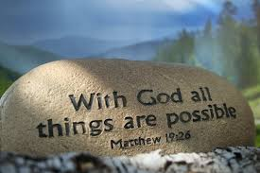

Yours in Christ
Ed

